**DAILY ONLINE ACTIVITIES SUMMARY**

|  |  |  |  |  |  |  |  |  |
| --- | --- | --- | --- | --- | --- | --- | --- | --- |
| **Date:** | **09-06-2020** | | | | | **Name:** | **Dhanush Shetty** | |
| **Sem & Sec** | **8 A** | | | | | **USN:** | **4AL16CS032** | |
| **Online Test Summary** | | | | | | | | |
| **Subject** | | **BDA** | | | | | | |
| **Max. Marks** | | **30** | | **Score** | | | **20** | |
| **Certification Course Summary** | | | | | | | | |
| **Course** | **Introduction to Amazon Simple Queue Service.** | | | | | | | |
| **Certificate Provider** | | | **AWS** | | **Duration** | | | **10 mins** |
| **Coding Challenges** | | | | | | | | |
| **Problem Statement:**   1. **Write a C Program to rotate the matrix by K times.** | | | | | | | | |
| **Status: Solved** | | | | | | | | |
| **Uploaded the report in Github** | | | | | **Yes** | | | |
| **If yes Repository name** | | | | | **Dhanushshett/online_c_coding_repository** | | | |
| **Uploaded the report in slack** | | | | | **Yes** | | | |

Online Test Details:

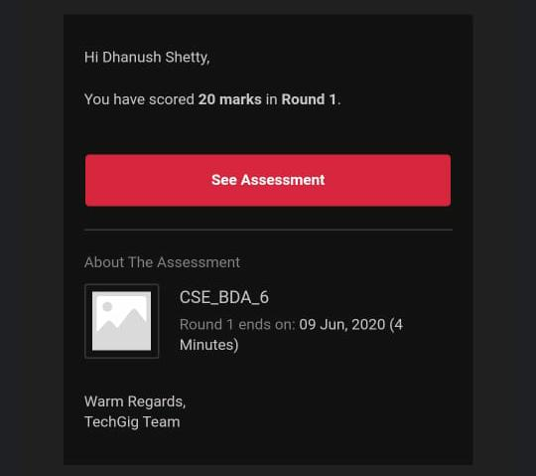

Certification Course Details:

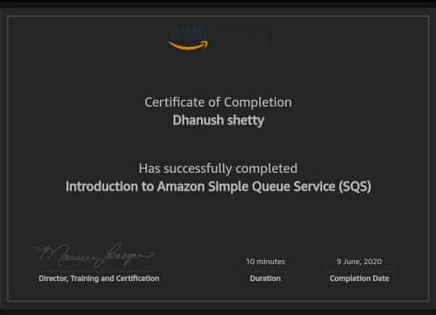

Coding Challenges Details:

**PROGRAM 1 .**

**//Write a C Program to rotate the matrix by K times**

**#include<stdio.h>**

**#define M 3**

**#define N 3**

**void rotateMatrix(int matrix[][M], int k) {**

**int temp[M];**

**k = k % M;**

**for (int i = 0; i < N; i++) {**

**for (int t = 0; t < M - k; t++)**

**temp[t] = matrix[i][t];**

**for (int j = M - k; j < M; j++)**

**matrix[i][j - M + k] = matrix[i][j];**

**for (int j = k; j < M; j++)**

**matrix[i][j] = temp[j - k];**

**}**

**}**

**void displayMatrix(int matrix[][M]) {**

**for (int i = 0; i < N; i++) {**

**for (int j = 0; j < M; j++)**

**printf("%d",matrix[i][j]);**

**printf("\n");**

**}**

**}**

**int main() {**

**int matrix[N][M] = {{10, 20, 30},**

**{40, 50, 60},**

**{70, 80, 90}};**

**int k = 2;**

**rotateMatrix(matrix, k);**

**displayMatrix(matrix);**

**return 0;**

**}**